H.T No
Regulations:
A20

Sreenidhi Institute of Science and Technology
(An Autonomous Institution)
Code No:8HC10 Date: 31-Jan-2024 (AN)

B.Tech I-Year I- Semester External Examination, Jan/Feb-2024 (Supplementary)
LINEAR ALGEBRA AND CALCULAS (CSE,IT,ECM)

Time: 3 Hours Max.Marks:70

Note: a) No additional answer sheets will be provided.
b) All sub-parts of a question must be answered at one place only, otherwise it will not be valued.
c) Missing data can be assumed suitably.
Bloom's Cognitive Levels of Learning (BCLL)

Remember | L1 | Apply | L3 | Evaluate | L5
Understand | L2 | Analyze | L4 | Create | L6

Part - A Max.Marks:20

Answer all QUESTIONS.

 |  | BCLL | CO(s) | Marks
1 | Is the matrix 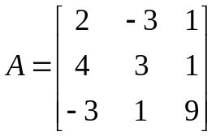is orthogonal? | L3 | CO1 | [2M]
2 | Define Unitary Matrix and give an example. | L1 | CO2 | [2M]
3 | Define Linear combination of vectors | L1 | CO3 | [2M]
4 | Define linear functional on inner product space. | L1 | CO4 | [2M]
5 | Verify Rolle’s theorem for 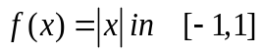 | L3 | CO5 | [2M]
6 | Express 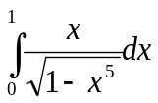 as beta function | L4 | CO6 | [2M]
7 | Define rank of a matrix. | L1 | CO | [2M]
8 | Define Kernal and image of a Linear Transformation | L1 | CO | [2M]
9 | Expand the sin(x) using Maclaurin’s series | L3 | CO | [2M]
10 | Find the sum and product of the eigen values of the matrix 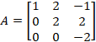 | L1 | CO | [2M]

Part – B Max.Marks:50
ANSWER ANY FIVE QUESTIONS. EACH QUESTION CARRIES 10 MARKS.

 |  |  | BCLL | CO(s) | Marks
11. | a) | Find the rank of a matrix by reducing it into normal form where 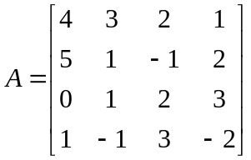 | L1 | CO1 | [5M]
 | b) | Solve the following system of equations using Gaussian elimination method | L3 | CO1 | [5M]
12. |  | Diagonalize the matrix 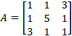 and hence find A⁴ | L3 | CO2 | [10M]
13. | a) | Determine the matrix of the linear map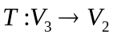, T(x, y, z) = (y + z, y - z) with respect to the ordered basis. | L5 | CO3 | [5M]
 | b) | Let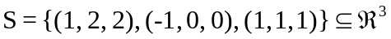. Find a basis of the subspace spanned by S | L1 | CO3 | [5M]
14. | a) | Write the basic properties of orthogonal complement | L2 | CO4 | [5M]
 | b) | Suppose 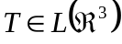 has an upper-triangular matrix with respect to the basis (1, 0, 0), (1, 1, 1),(1, 1, 2). Find an orthonormal basis of 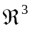(use the usual inner product on ) with respect to which T has an upper - triangular matrix. | L3 | CO4 | [5M]
15. | a) | Verify CMVT to the function f(x) = e^{x} and g(x)= e^{-x} in the interval [a,b] | L3 | CO5 | [5M]
 | b) | Prove that 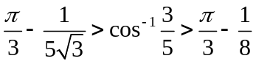 using Lagrange’s mean value theorem | L5 | CO5 | [5M]
16. | a) | Evaluate 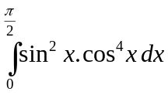, using Beta and Gamma functions. | L3 | CO6 | [5M]
 | b) | Show that 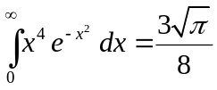 | L1 | CO6 | [5M]
17. | a) | Solve the following system of equations x + 3y – 2z =0, 2x – y + 4z = 0,  x – 11y + 14z = 0 | L3 | CO1 | [5M]
 | b) | Verify Cayley-Hamilton theorem for 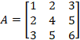 | L5 | CO2 | [5M]
18. | a) | Expand e^{x} about x=1 | L3 | CO5 | [5M]
 | b) | Prove that 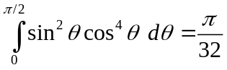 | L2 | CO6 | [5M]
-- 00 -- 00 –

